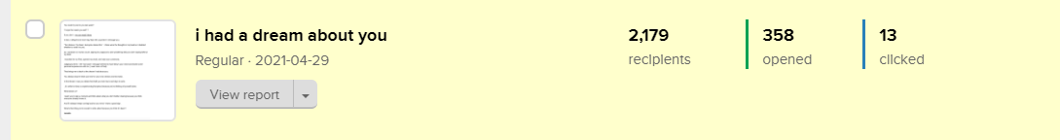
358 people opened this email: https://preview.mailerlite.com/s0s6s4
-------------------------------------------------

Headline: i had a dream about you
———————————————-

You recall my text to you last week?

"i hope this meets you well" ?

If you don't - you can read it here.

In fact, I delayed one more day than the usual time I message you.

"Too obvious. Too basic. Everyone knows this." - those were the thoughts that ran through my head as I wondered whether to send it to you.

As I sat down on my fav couch, sipping my cappuccino (and wondering what you were saying behind my back).

I reached for my iPad, opened my email, and read your comments.

Judging by them - the "too basic" message seemed to have blown your mind and shared some personal experiences with me. (i want more of that).

That brings me to back to my dream about you;

You always assume what you have to say is too obvious and too basic.

In that dream I saw you delete that draft you took hours and days to write.

$name, it's unfair to deny us experiencing that piece because you're thinking of yourself alone.

What about us?

I want you to take a moment and think about what you don't bother sharing because you think everyone already knows it.

And if it always keeps coming back to your mind - that's a good sign.

What's that thing you're scared to write about because you think it's basic?

Lamide.

